CMR-CHECKS Installation Manual

|  |  |
| --- | --- |
| **Organisational unit:** | [Level] |
| **Owner:** | Framework Team |
| **Version:** | **1.0** |
| **Effective from:** | 01.09.2015 |

|  |  |  |  |
| --- | --- | --- | --- |
| Document Details | | | |
| Name | CMR CHECKS | | |
| (Lead) Author | Andrei Popovici | | |
| Document Owner / OU | Framework Team | | |
| Content Summary |  | | |
| Classification level | [Level] | Superior group document |  |
| Impacted Division | ... | | |
| Application | Legal entities it applies to | | |
| Disclosure | Public | | |
| Publication | Erste Open Network | | |
| Next review date | 1 year after approval/review | | |
| Valid until: | 31.12.15 | | |
| Superior working instruction | Title | | |

|  |  |  |  |
| --- | --- | --- | --- |
| History | Changes | Approval Date | Approved by |
|  |  |  |  |
|  |  |  |  |
|  |  |  |  |

|  |  |
| --- | --- |
| Approvals | |
| Approval level required |  |
| Reason for approval request | e.g. change of process |
| Date of final approval | 01.09.2015 |

|  |
| --- |
| Distribution list |
| Unit / Function |
|  |
|  |
|  |
|  |
|  |
|  |
|  |

# Table of Contents

1. Table of Contents 3

2. Summary 4

3. Installation Prerequisites 5

3.1 Database 5

3.2 JVM 5

3.3 Physical Location 5

4. Installation Steps 6

4.1 Database 6

4.2 Application 6

5. Installation Verification 8

# Summary

This document describes how to install and verify that the installation for the CMR-CHECKS. The application has to major components

* A database component
* A JAVA component

For both of them there are some prerequisites and for both of them a sequence of steps needed to be executed are provide in the following chapters.

# Installation Prerequisites

## Database

* The database must be Oracle 11g or lower.
* A dedicated user and a dedicated schema must be created for this application. You can create the database objects for the application in the CMR schema, but the recommended approach is to use a dedicated schema
* The user must read select writes on all database objects that will be used when defining the checks. As a guideline the user should have access to at least CMR, STAGE, CORE, STAGE SEMANTIC and SEMANTIC schemas.
* The database listener must be accessible from the machine where the application will be installed.

## JVM

* A JVM 1.7 or higher is required in the machine where the application will be installed.
* JAVA_HOME environment variable must point to the JVM installation.

## Physical Location

* From the machine where the JVM resides and the application will be installed the database must be accessible.
* IF the CMR checks will be run also by ODI agent than that agent must be able to launch the application and this usually means that the ODI agent must be on the same machine.
* Unzip in the folder of choice the release artefact CMR-CHECK-v{M.mm}.zip that you have received. The contents of the location where you unzipped should look like this

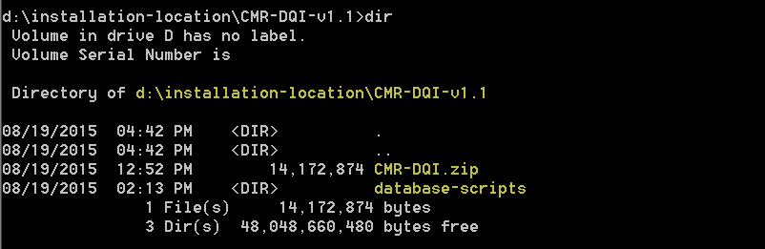

From now on the installation location will be referred to as %installation-location% and paths mentioned in this document will be written as some-directory/another-directory/file-of-interest.ext.

Example:

installation-location%/database-scripts/cmr-check-ddl.sql

# Installation Steps

## Database

1. Login with the user you have created for this application (Please see the Installation Prerequisites for the Database).
2. Run the DDL script cmr-check-ddl.sql that you can find in the folder %installation-location%/database-scripts. It is very important that the user used by the application to connect to the database to OWN the objects created by this script!
3. After the script is run, you should see in the schema the newly created tables and the sequence used by the application. Please check if you find all the tables form the image below in your schema.

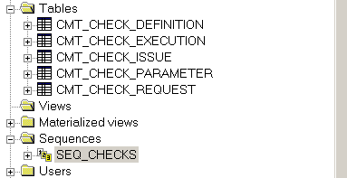

## Application

In the %installation-location% unzip de the CMR-DQI.zip. You will now have a new folder CMR-DQI and inside that folder you will have other subfolders bin and zip. Please use the images below to check if you have the same structure.

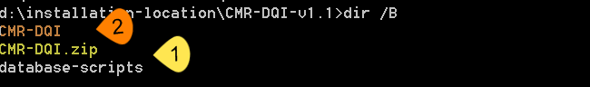



1. Go into the subfolder folder lib/conf and edit the file cmr_check.properties. In this file you can set the properties of the application.
2. If you want to set up the connection to the database use the properties with the names that have with “*database.*”prefix.
   1. database.url – is the JDBC URL for the database. It must be in the jdbc thin oracle url format. An example is provided in the file.
   2. database.username – the username used to create the connections, authenticate and authorize the operations against the database. Please keep in mind that it must have access to the application tables and also to the other database objects used in the definition of CHECKS.
   3. database.password – the password for the user used to connect to the database. It must be provided unencrypted/
3. If you want to set up the logging for the application use the properties with the names that have the “log.” prefix
   1. log.fileName – if you want the application to record the logs in files (rolling files, max 3) please use this option to specify the full path for the log file. Any folder in the path, which does not exist must be created prior to the application execution. The actual log file will be created by the application if it does not exist. Please make sure that the user under which the application runs can write into the specified path. Please use as path separator the character “/”. Example: %installation-location%/CMR-DQI-v1.1/logs/cmr-dqi.log
   2. log.console – enables (true) or disables (false) the display of logging messages in the console. Recommendation is to leave it on false not to affect the execution of the application from an external application (ODI).
   3. log.level – sets the level of detail that will be recorded in the files and/or displayed into the console.

# Installation Verification

1. Go to the %installation-location%/CMR-DQI/bin.
2. Lunch the application using the command:

CMR-DQI.bat

Don’t worry if you see an error message. We have not provided any parameter, just please check that it is the error message from the print screen below.

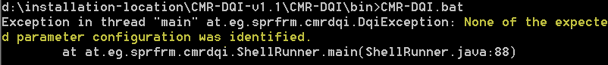

If you have received any other error please check the JVM location and if “JAVA_HOME” environment variable is set up properly.

1. Once you have completed the previous step please run the following command

CMR-DQI.bat DUMMY_PARAMETER "" ""

If you have run this command without any errors (please check the log file) then the installation is successful. Below you will find a print screen with the end of the log file after a successful run.

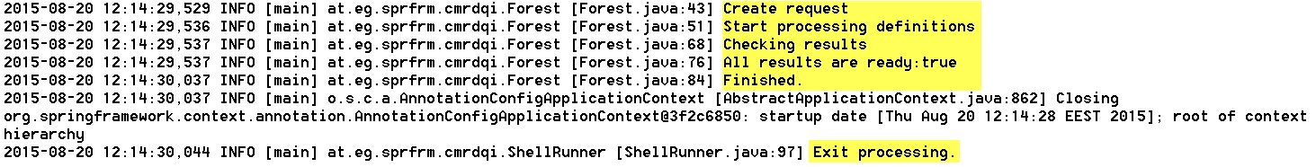

Note: In the print screen providers the application was configured not to write output to console, only to file and the level of detail needed for logs was set to INFO.